Travail à la maison du 4 au 8 mai 2020 - 5ème

- Lundi 4 Mai : Séquence 3 – A hero like no other!

Mission 1: Keep calm, or call Ironman!

Did you know? Read the text and answer the questions.
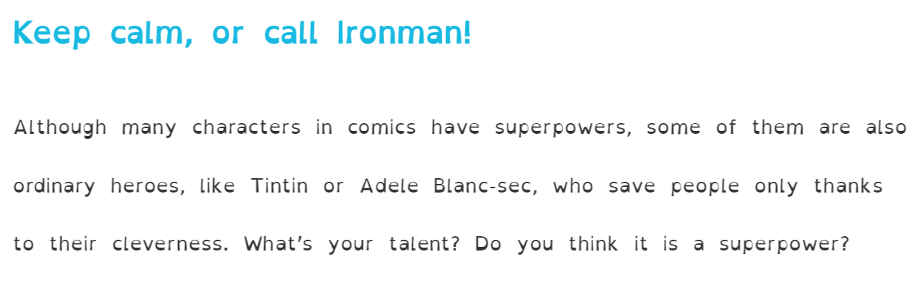
- Right or Wrong?
1. Tintin and Adèle Blanc-Sec are real-life heroes. □ Right □ Wrong
2. What is Tintin and Adèle Blanc-Sec’s talent? □ They are clever □ They can run fast □ They can read minds

- Check your answers using the correction.
1. Tintin and Adèle Blanc-Sec are real-life heroes. Right
2. What is Tintin and Adèle Blanc-Sec’s talent? They are clever

- A job for superheroes!
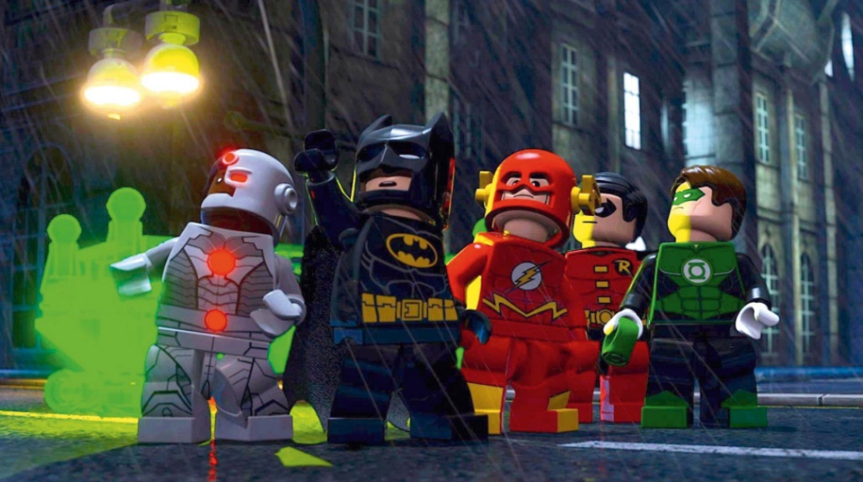
Question 1:
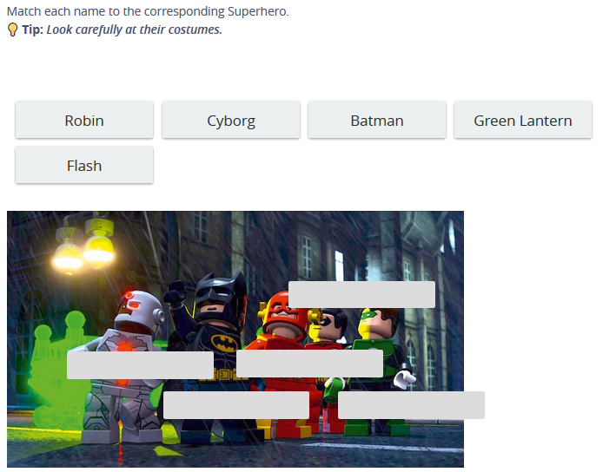

Question 2:
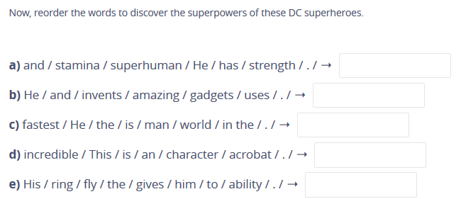

Question 3:
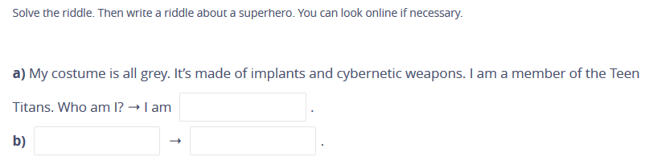
- Check your answers using the correction.
Question 1:
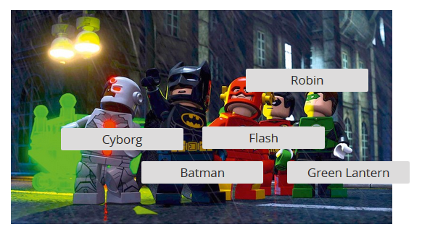

Question 2:

a) Cyborg: He has superhuman strength and stamina.
b) Batman: He invents and uses amazing gadgets.
c) Flash: He is the fastest man in the world.
d) Robin: This is an incredible acrobat character.
e) Green Lantern: His ring gives him the ability to fly.

Question 3:

a) I am Cyborg.
b) I wear a black cape and I don’t have any superpower but I use gadgets. I have a car. ➝ I am Batman.

- Mardi 5 Mai : Production écrite

Travail à rendre via l’adresse mail romanehery@yahoo.com ou à la rentrée (5 Phrases minimum).

Choose one superhero, select a picture of him or her and write his or her biography!

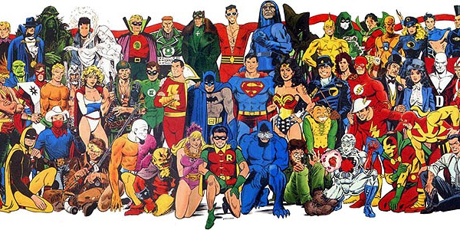

- Vendredi 8 Mai : Séquence 3 – A hero like no other!

- Lesson 1: A job for superheroes!

My superhero’s name is Batman. He was created in 1939. He lives in Gotham. He is American. He doesn’t have any superpower. He invents and uses amazing gadgets.

- Grammar: Les capacités
▪ Can → ability
▪ Can’t → inability, incapacity

- Exercice 1 page 134:
Pick your hero’s abilities and inabilities. Write sentences to present your hero abilities and inabilities.
    - run the 100 meters
    - read people’s minds
    - travel in time
    - turn invisible
    - lift 1000 lbs
    - heal people
    - breathe underwater
    - speak seven languages
    - control the weather
    - talk to animals

- Check your answers using the correction.

He can run the 100 meters. He can’t read people’s minds. He can travel in time. He can’t turn invisible. He can lift 1000 lbs. He can’t heal people. He can breathe underwater. He can’t speak seven languages. He can control the weather. He can’t talk to animals.

