Travail à la maison du 18 au 22 mai 2020 - 6ème

- Lundi 18 Mai : Révision

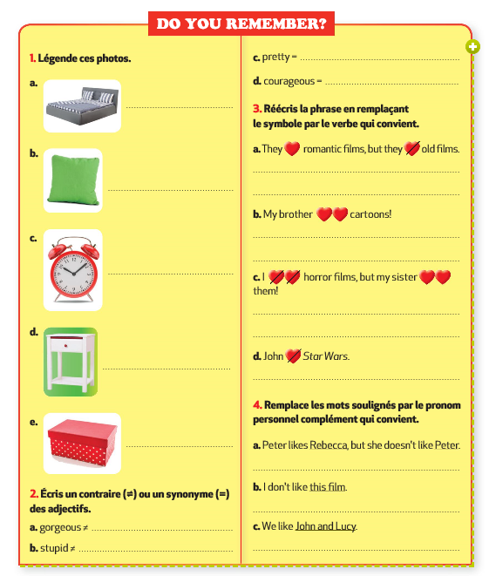

- Vérifie tes réponses avec la correction.

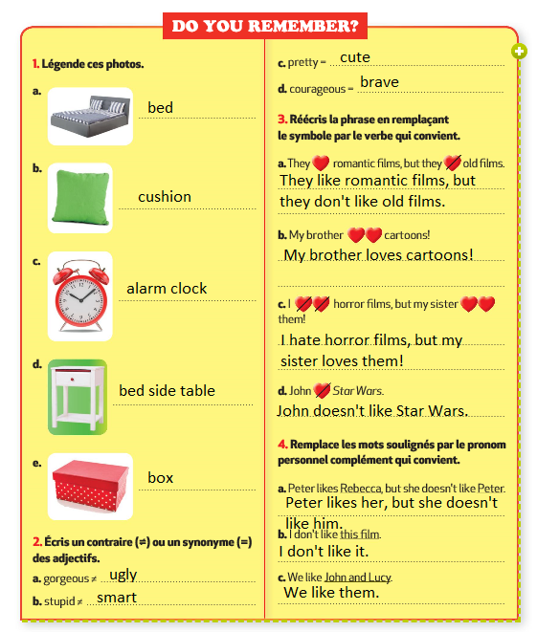

- Mardi 19 Mai : Flashtest

Travail à render via l’adresse mail RomaneHery@yahoo.com.

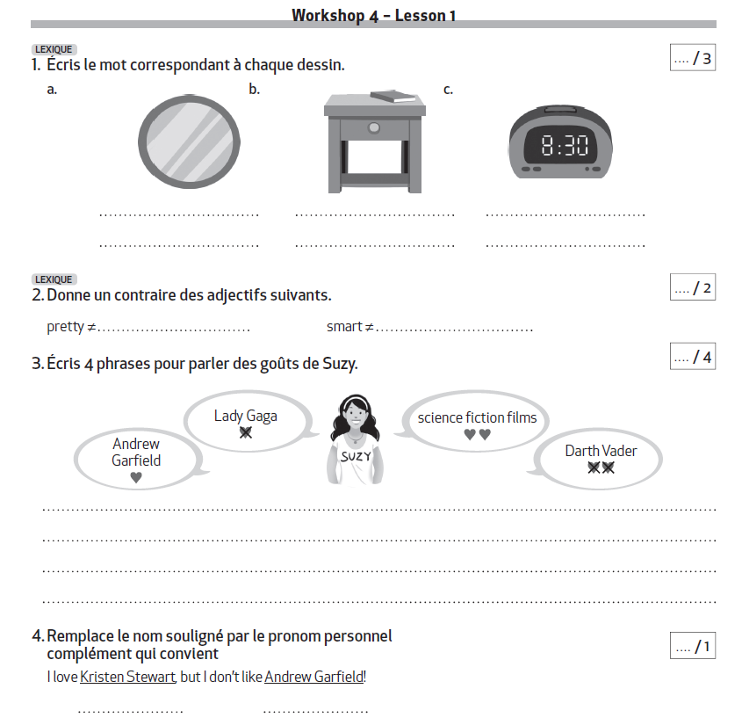

- Mercredi 20 Mai : Prepare your project

Travail à render via l’adresse mail RomaneHery@yahoo.com.

Choisis un poster pour décorer ta chambre et explique ton choix. Utilise le nouveau vocabulaire, les verbes de goût et les pronoms personnels compléments. Ecris au moins 5 phrases.
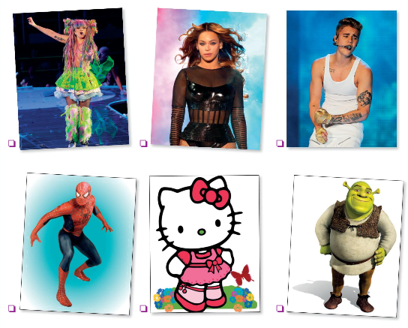

___________________________________________________________________________

___________________________________________________________________________

___________________________________________________________________________

___________________________________________________________________________

___________________________________________________________________________

- Vendredi 22 Mai : Welcome to my house!

Lesson 2: Visit a British house.

Compréhension écrite :
Lis le script de la vidéo et répond aux questions.

SCRIPT

Wendy. Look Jason, this is my street!
Jason. Wow, I like all these red houses. The windows are cool!
Wendy. They’re bow windows. They’re in the living room in British houses.
Wendy. Mum, we’re here!
Mrs Jones. Oh, hello Jason! Welcome to our house!
Jason. Thank you, Auntie Barbara. //
Wendy. Jason, let’s visit my house! So this is the living room with the sofas and the TV set. It’s my favourite place. I love reading here!
Mrs Jones. And we love watching TV together. Oh, no Rex! Rex loves sleeping on the sofa! //
Wendy. He likes sleeping on my bed too. You see, my bedroom is upstairs and he often goes there.
Jason. I see, how many bedrooms are there?
Wendy. There are three: one for my parents, one for my sister and one for me.
Jason. There are three bedrooms in my house too!
Wendy. Now the dining room. We have dinner here at 6.
Jason. At 6? This is early, we have dinner at 7 in
America. //
Wendy. And this is the kitchen. It’s my father’s favourite place. He loves cooking!
Jason. What does he like making?
Wendy. Chocolate cakes! They’re delicious! I love them! Do you like cooking? //
Jason. Yes, I do. I love cooking.
Mrs Jones. Oh great, so you prepare the dinner
tonight!
Jason. Me?!?
Mrs Jones. I’m joking!

- Circle the objects Wendy mentions.

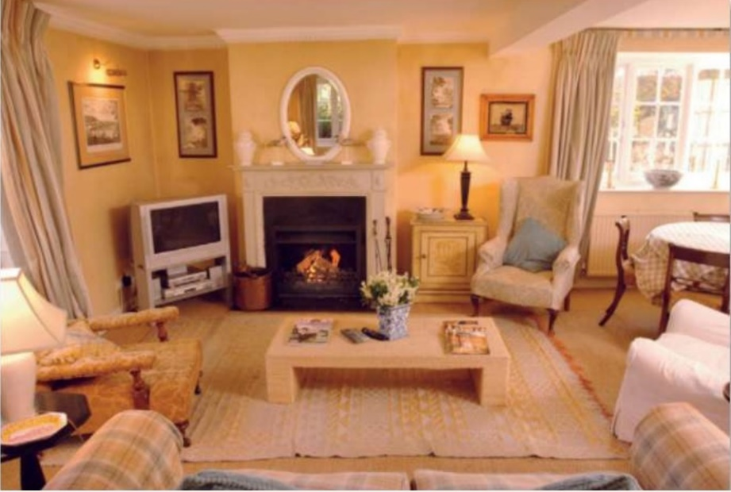
- Tick the rooms Wendy mentions.
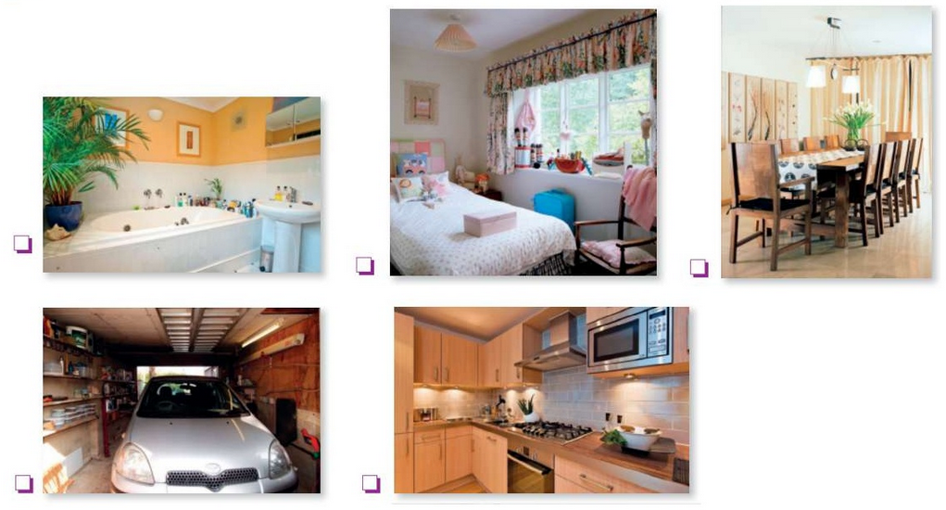

- Tick the right answer.
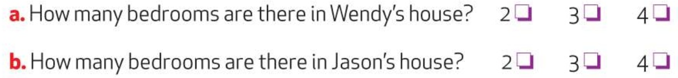

- Link the person to his/her favourite activity.
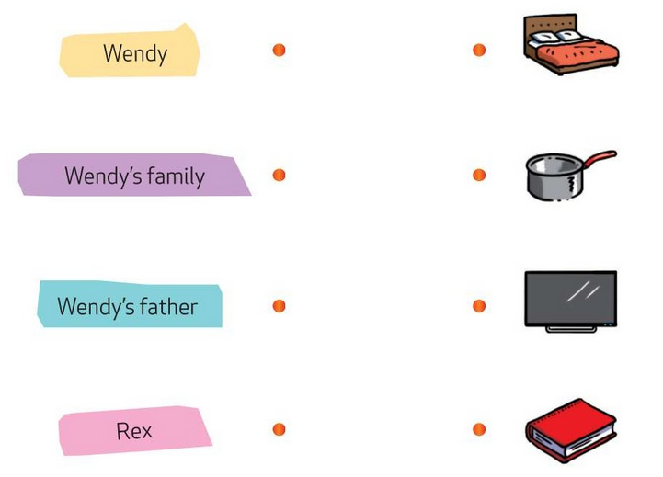

- RECAP. Complete the sentences.
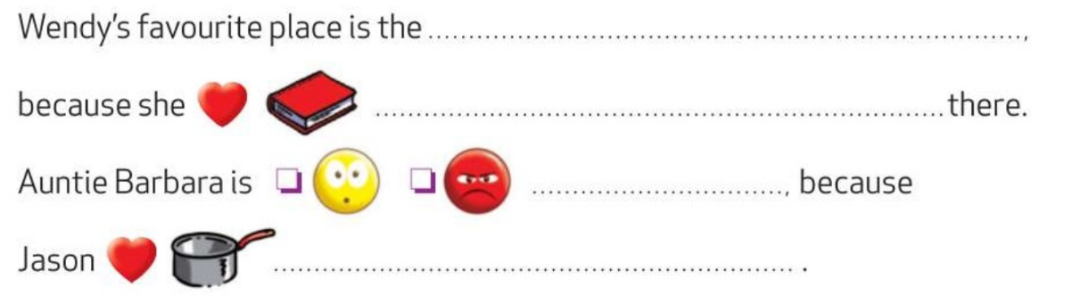

- Vérifie tes réponses avec la correction :

